# **Task F**

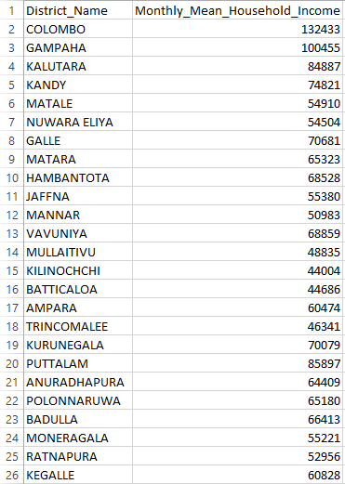

Figure 23

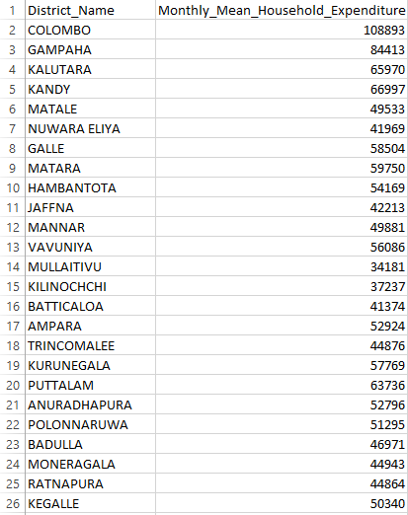

Figure 24

## **Hypothetical Chart**

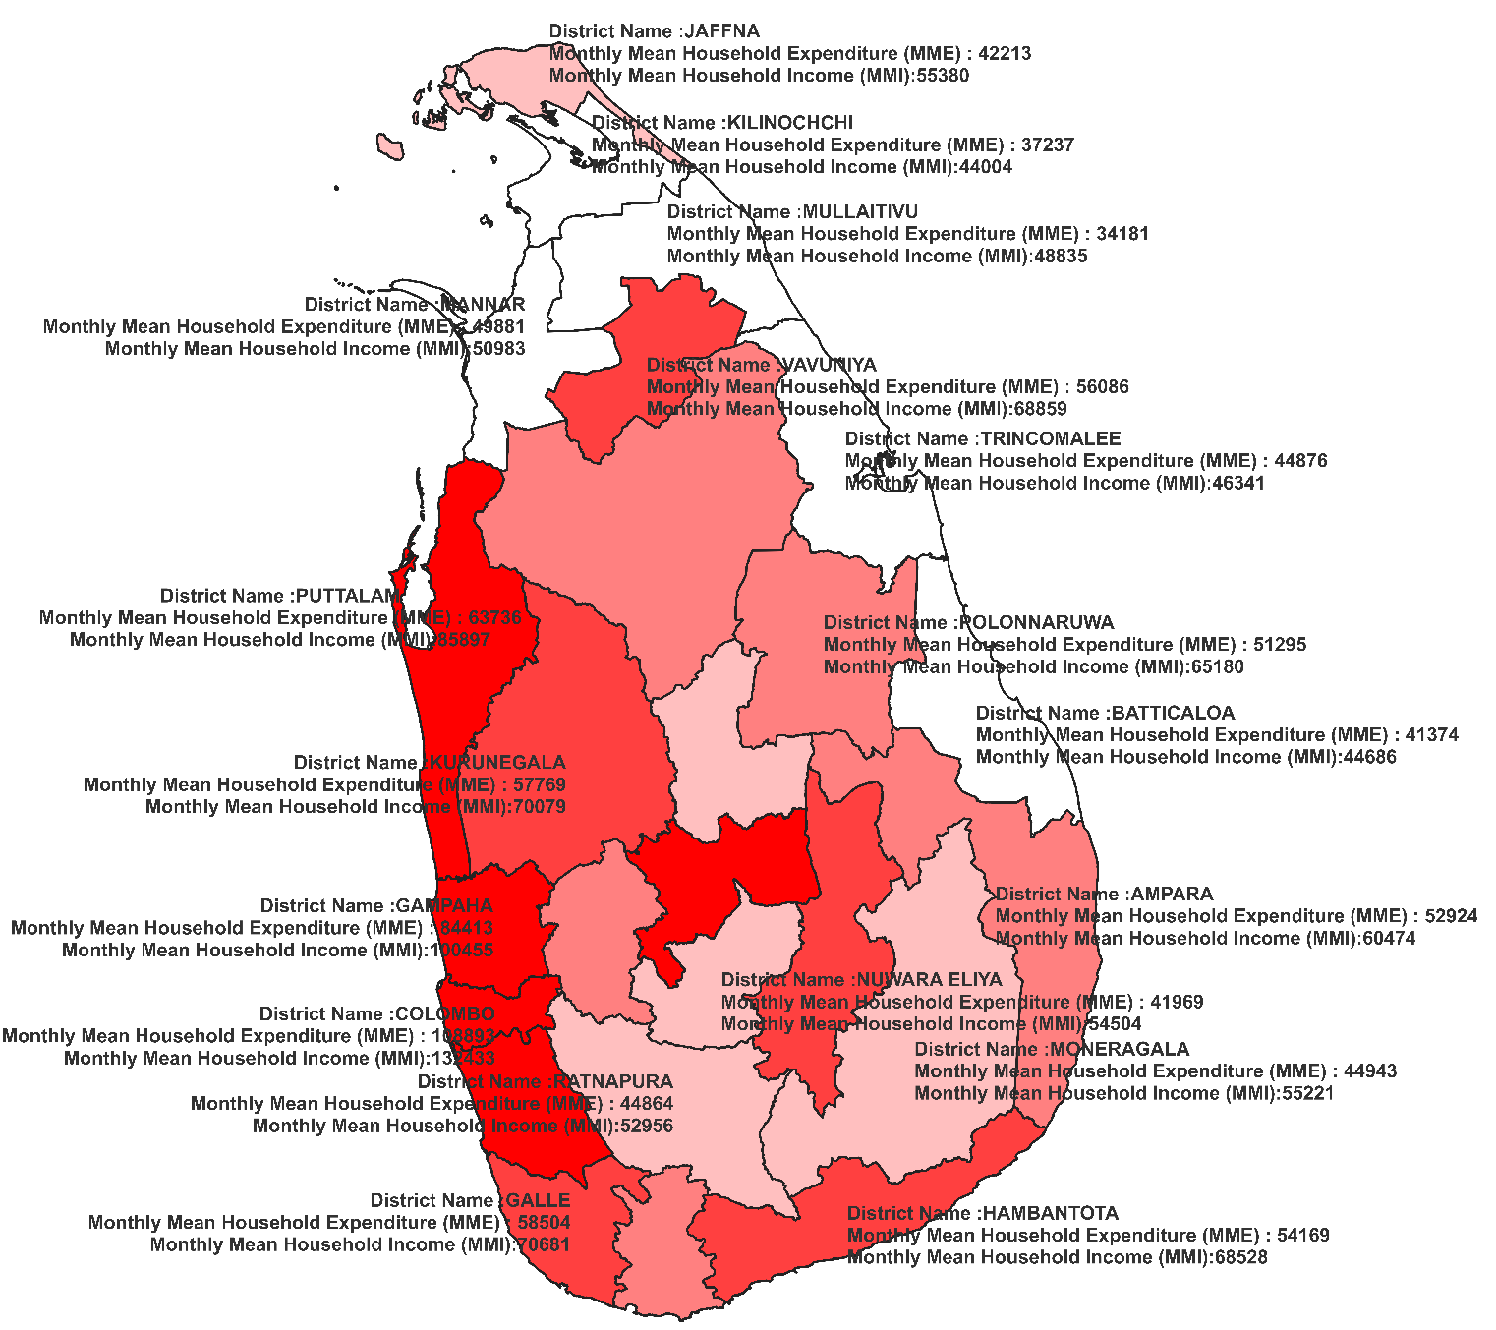

Figure 25

## **Comprehensive Chart**

**Monthly Mean Household Income in 20219**

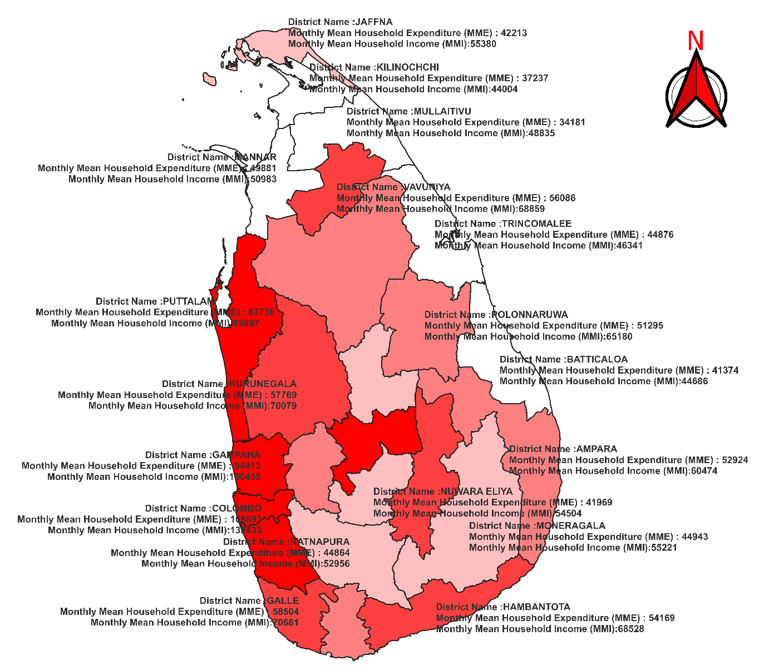 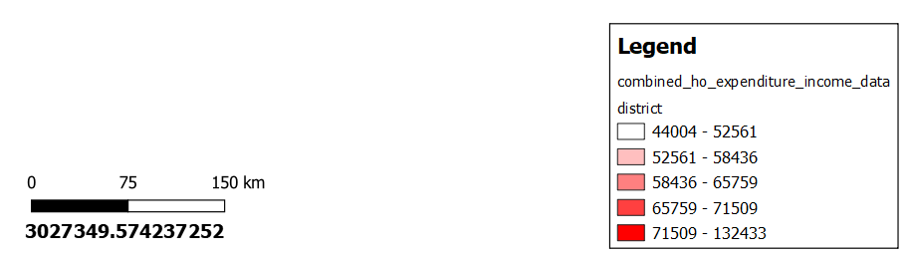

Figure 26

**Regional Wage and Expenditure Disparities:**

To make it easier to see how different regions' economies stack up against one another, the chart uses a color-coded method to distinguish between areas with low and high average household wages.

**Lower Average Wages (White Color Coding)**

* **Mullaitivu**: The long-term effects of the battle and the region's geographical isolation make life difficult. Wage levels and spending habits have fallen as a result of the sluggish economic recovery. There are fewer job openings and lower average salaries because of bureaucratic inefficiencies and poor infrastructure, which further impede economic progress.
* **Mannar**: The economic conditions in Mannar are still hampered by poor infrastructure upgrades and limited industrial development, even though incomes are relatively higher compared to certain neighboring areas. There is a tight financial position in the area, since households spend a large amount of their income on necessary requirements, and expenditure levels are tightly aligned with income.
* **Kilinochchi**: Kilinochchi, like Mullaitivu, is hindered by its far location and the continuous process of healing from conflict. Residents' reduced spending and incomes are a reflection of the economic challenges they confront, which include restricted access to goods and services.

**Higher Average Wages (Red Color Coding)**

* **Colombo**: Colombo, as the commercial center of Sri Lanka, enjoys a highly developed economic climate. The high cost of living, numerous business prospects, and thriving economy are reflected in the high wages and expenditures. Greater revenues and expenditure are the result of investments in physical infrastructure and the growth of businesses.
* **Gampaha**: Because of its convenient location near Colombo, this area has seen a rise in the economy as a result of increased industrial and commercial activity. Spending and salary increase in Gampaha are signs of a flourishing economy and more employment possibilities.
* **Puttalam**: Rising salaries are a direct outcome of the region's thriving agricultural and trading economies. Rising incomes and living conditions in the area have led to a rise in consumer spending.

# **APPENDIX SEGMENT**

## **Task F**

* I initially utilised the PostgreSQL administration dashboard, PGAdmin, to establish an innovative database structure.

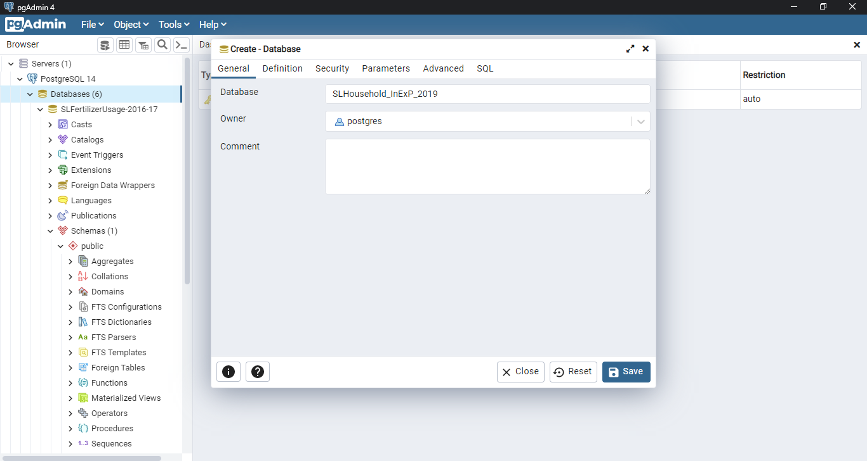

* I began here by designing a tabular architecture for income.

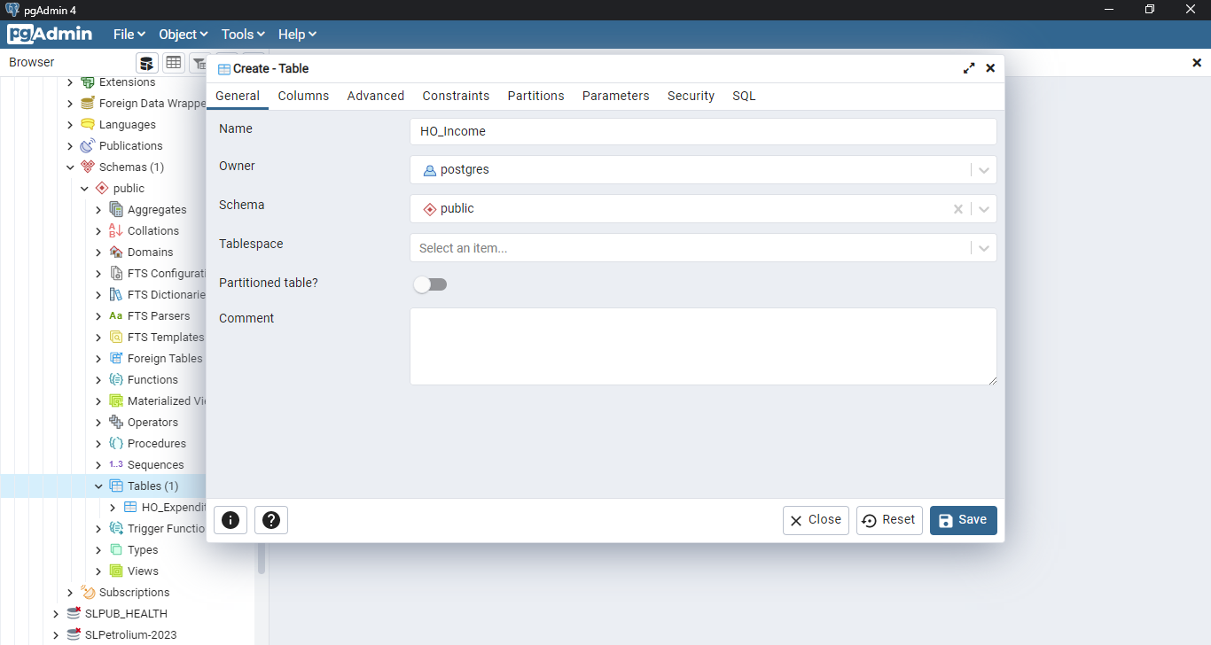

* Then I verified that the column titles were accurately aligned with the current terminology used for merging CSV data.

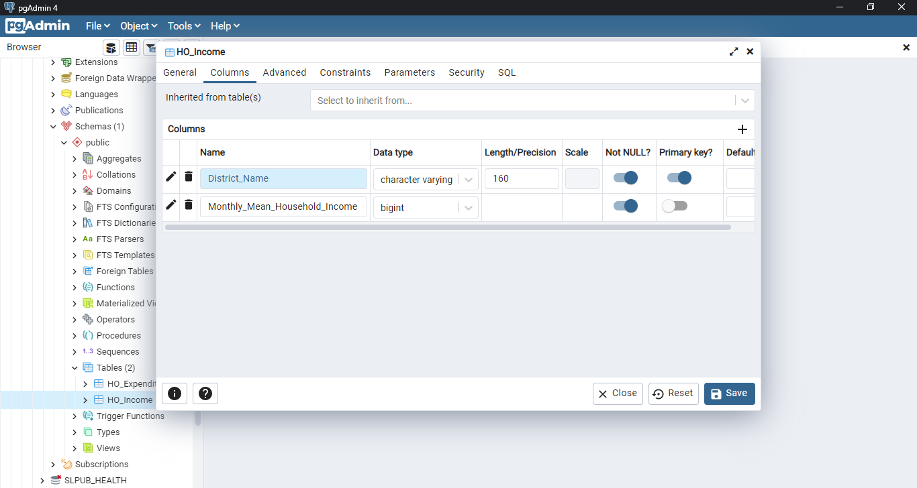

* Then I skilfully combined the CSV dataset into this elaborately designed table structure.

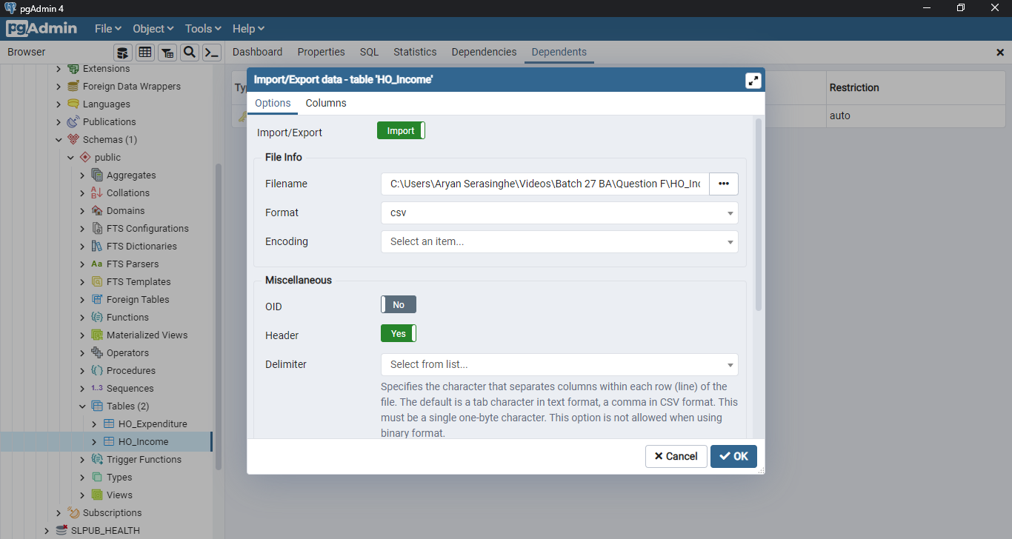

* Following this, PGAdmin issued a note indicating the data's accurate entanglement.

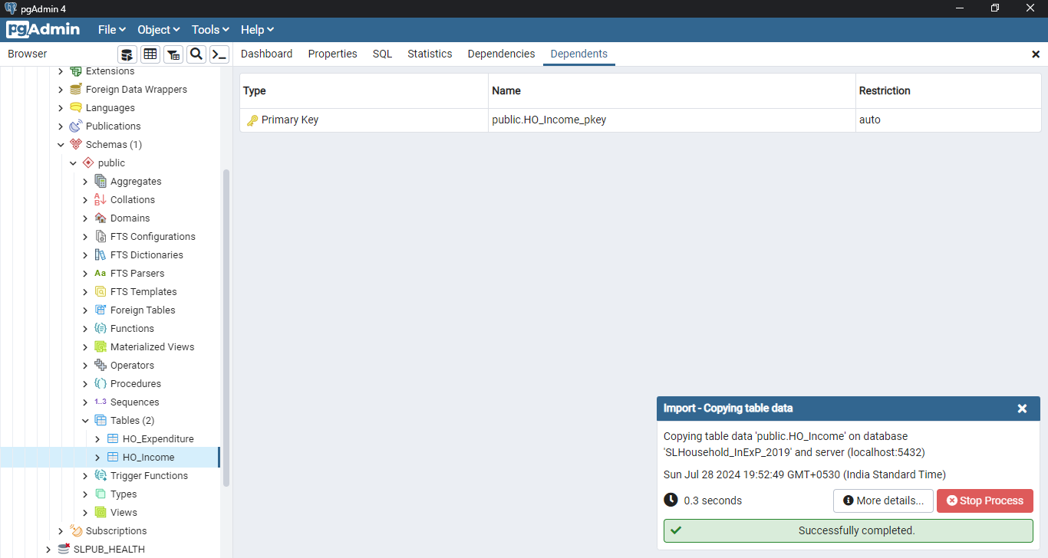

* Subsequently, I initiated the process by constructing a table to document expenses.

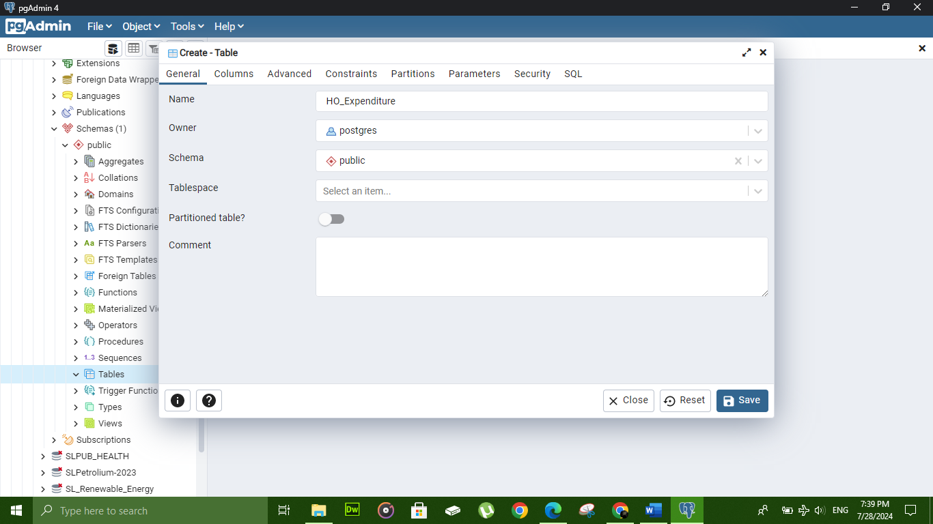

* Next, I filled all relevant columns with the correct names for the CSV data.

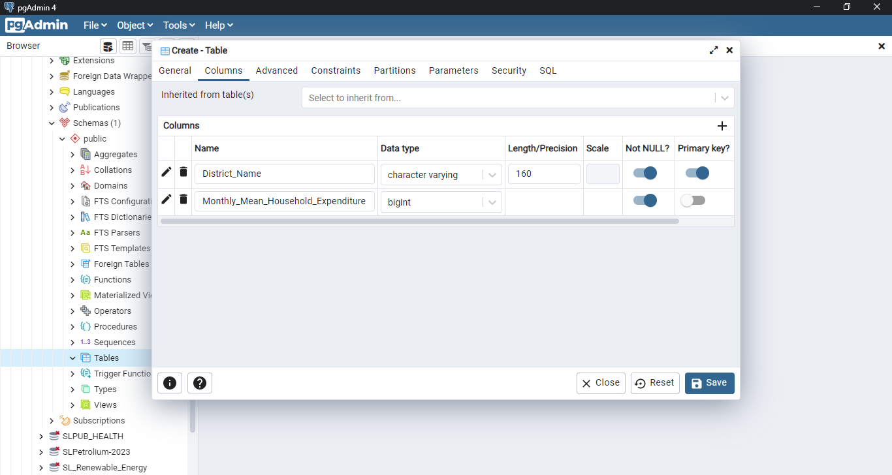

* I then adeptly integrated the CSV dataset into the carefully designed expenditure table.

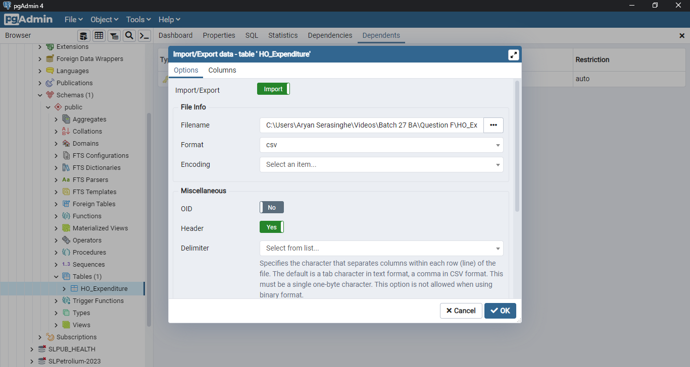

* Following this, PGAdmin issued a note indicating the data's accurate entanglement.

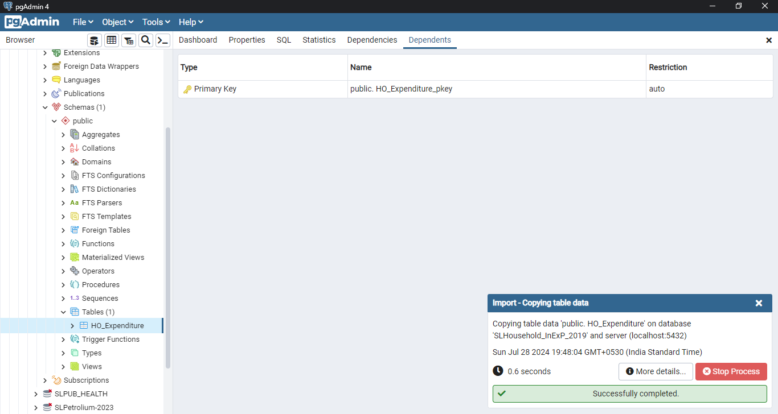

* Thereafter, I executed a JOIN operation to amalgamate both tables using SQL JOIN command.

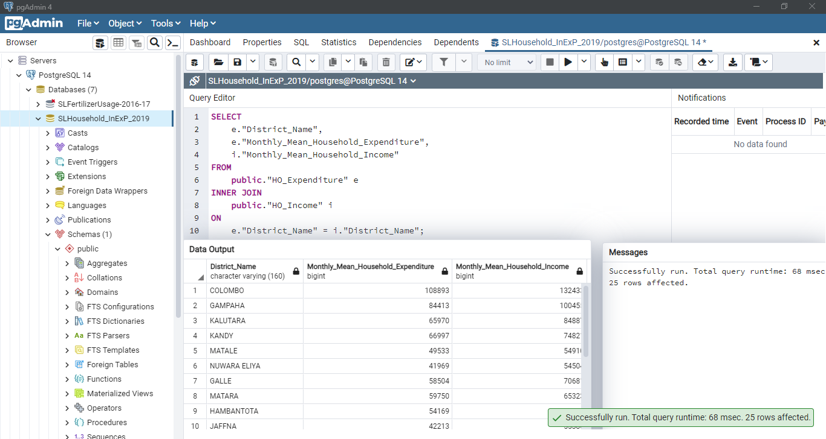

* I proceeded to create a view to facilitate comprehensive data analysis visualization.

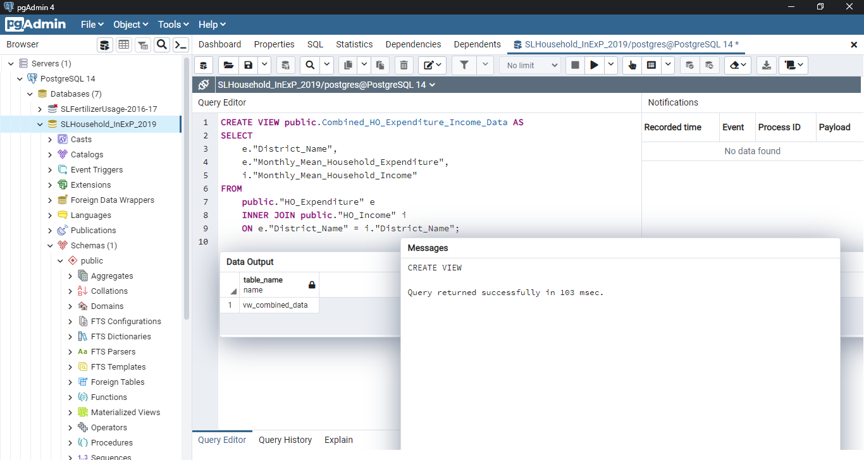

* Finally, I configured the POSTGIS extension to enable database integration with QGIS.

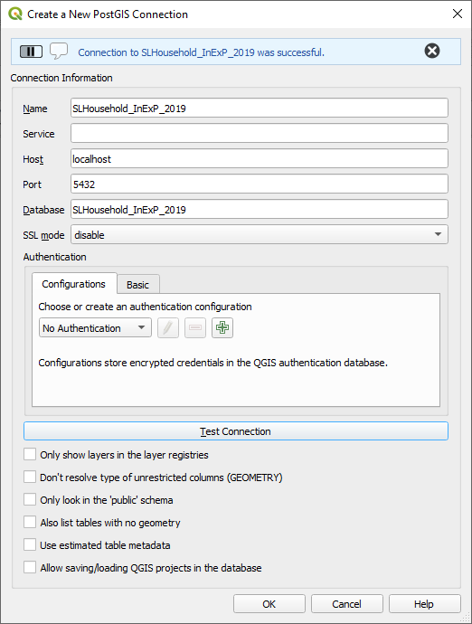

* Unassailable evidence of database integration.

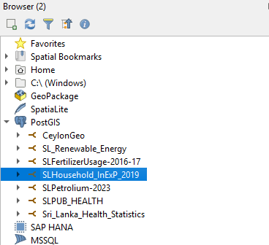

* Effectuate the embedment of our dataset into the canvas schema.

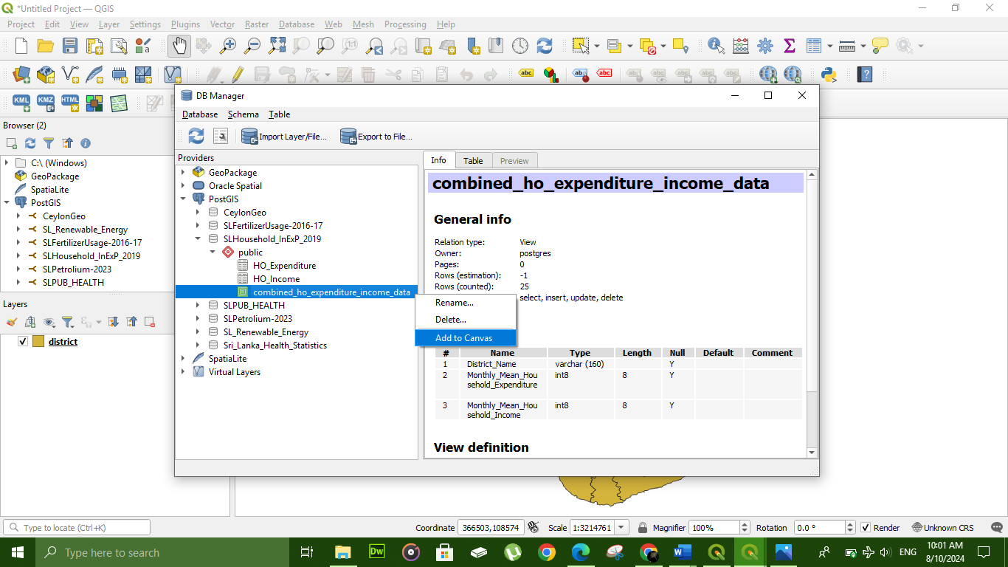

* Deploy "district.shp" as the principal geospatial overlay.

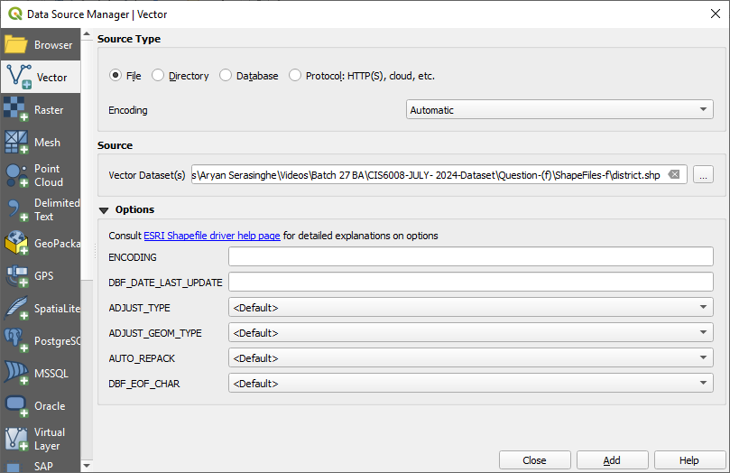

* Using a prismatic gradient to determine average household wages on a monthly basis for the calendar year 2019.

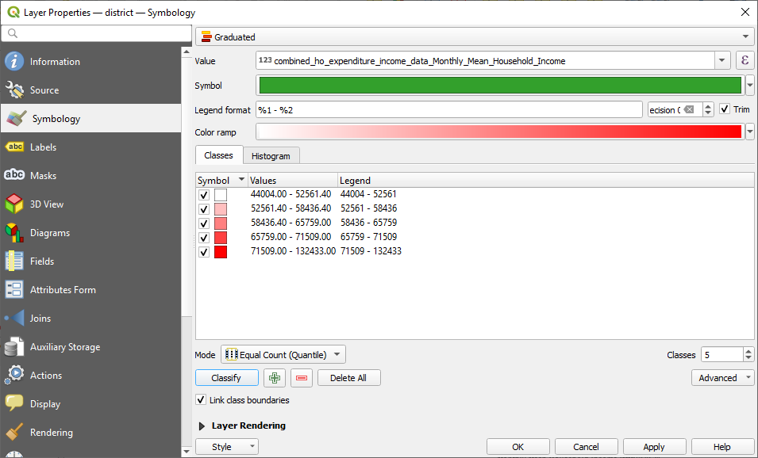

* Inscribe with inscriptions to improve textual clarity and facilitate maximal interpretive acuity.

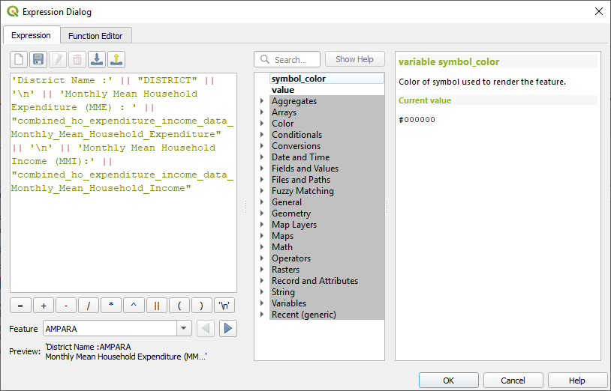

* Enshrined sophisticated partitioning subdivision diagram.

